 | Universidade Federal do Rio Grande do Norte  Centro de Tecnologia  Coordenação do Curso de Engenharia Mecatrônica | 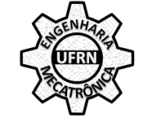

CERTIFICATE

I attest, for the given purposes, that the student Full Name, Enrollment Number XXXXXXX, is a regular student at Federal University of Rio Grande do Norte and is expected to graduate with a Bachelor’s Degree in Mechatronics Engineering in Date.

Natal, RN, May 26th of 2017.

________________________________________
Márcio Valério de Araújo
SIAPE NUMBER 2718169
Coordinator of the Mechatronics Engineering Major

